Implement Random forest ensemble method on a given dataset.

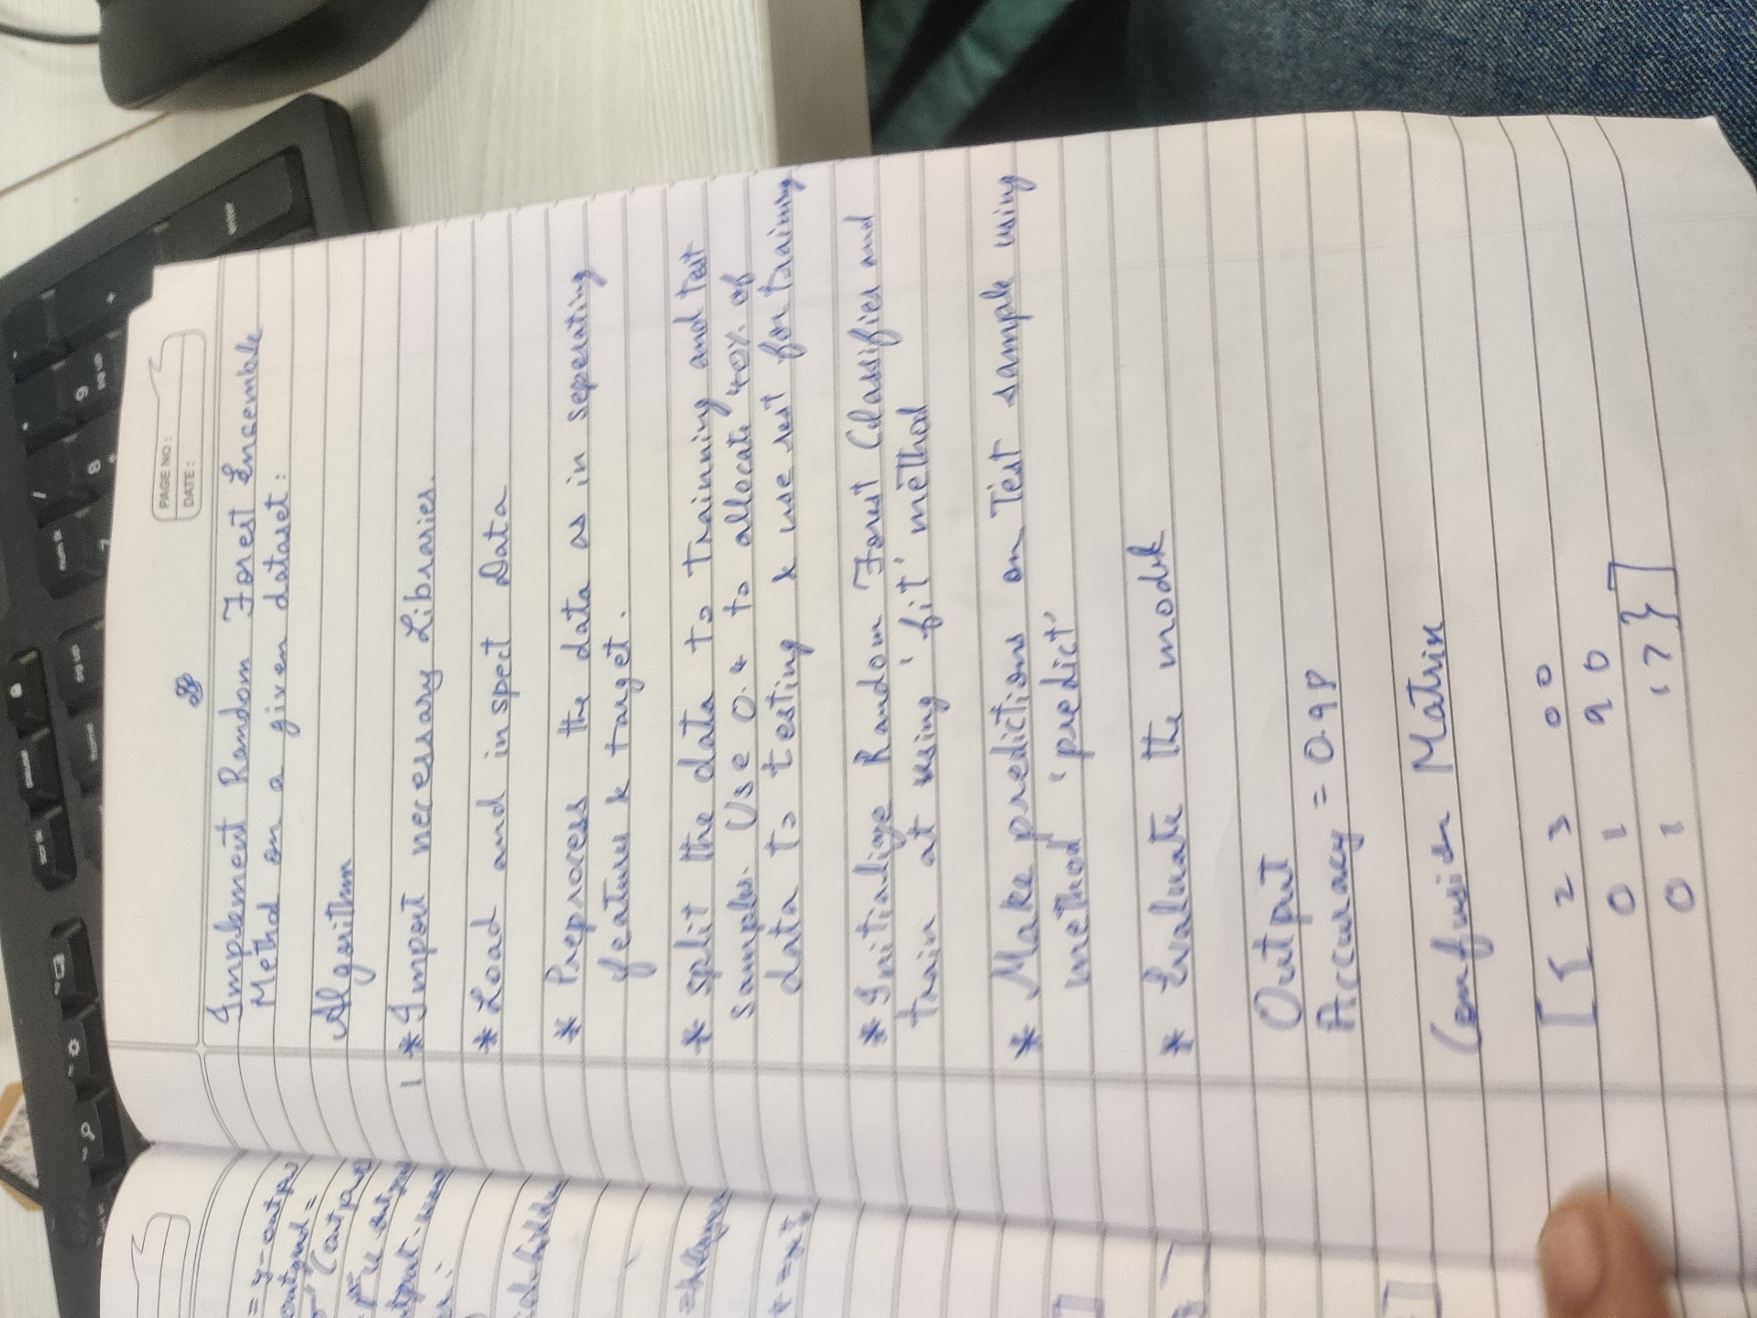

*Code:*

*# Pandas is used for data manipulation*

import pandas as pd

*# Read in data and display first 5 rows*

features = pd.read_csv('temps.csv')

features.head(5)

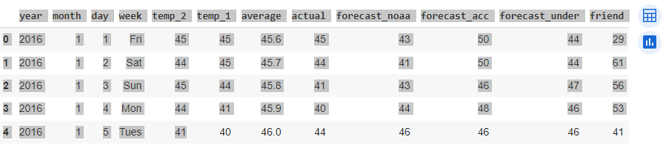

Out[1]:

In [2]:

print('The shape of our features is:', features.shape)

*# Descriptive statistics for each column*

features.describe()

The shape of our features is: (348, 12)

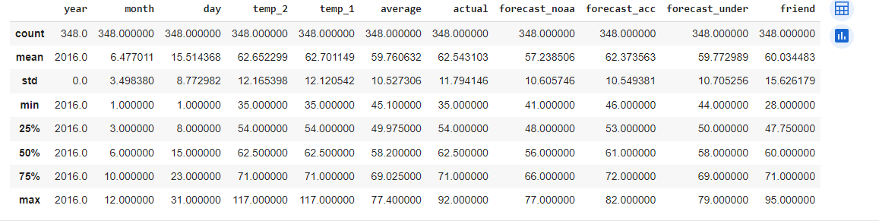Out[3]:

In [4]:

*# One-hot encode the data using pandas get_dummies*

features = pd.get_dummies(features)

*# Display the first 5 rows of the last 12 columns*

features.iloc[:,5:].head(5)

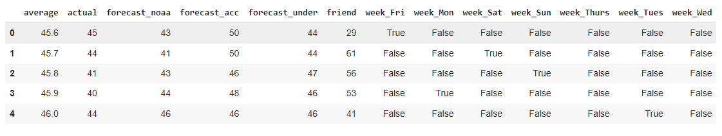

*# Use numpy to convert to arrays*

import numpy as np

*# Labels are the values we want to predict*

labels = np.array(features['actual'])

*# Remove the labels from the features*

*# axis 1 refers to the columns*

features= features.drop('actual', axis = 1)

*# Saving feature names for later use*

feature_list = list(features.columns)

*# Convert to numpy array*

features = np.array(features)

In [6]:

*# Using Skicit-learn to split data into training and testing sets*

from sklearn.model_selection import train_test_split

*# Split the data into training and testing sets*

train_features, test_features, train_labels, test_labels = train_test_split(features, labels, test_size = 0.25, random_state = 42)

In [9]:

print('Training Features Shape:', train_features.shape)

print('Training Labels Shape:', train_labels.shape)

print('Testing Features Shape:', test_features.shape)

print('Testing Labels Shape:', test_labels.shape)

Training Features Shape: (261, 17)

Training Labels Shape: (261,)

Testing Features Shape: (87, 17)

Testing Labels Shape: (87,)

In [10]:

*# The baseline predictions are the historical averages*

baseline_preds = test_features[:, feature_list.index('average')]

*# Baseline errors, and display average baseline error*

baseline_errors = abs(baseline_preds - test_labels)

print('Average baseline error: ', round(np.mean(baseline_errors), 2))

*# Import the model we are using*

from sklearn.ensemble import RandomForestRegressor

*# Instantiate model with 1000 decision trees*

rf = RandomForestRegressor(n_estimators = 1000, random_state = 42)

*# Train the model on training data*

rf.fit(train_features, train_labels);

Average baseline error: 5.06

In [11]:

*# Use the forest's predict method on the test data*

predictions = rf.predict(test_features)

*# Calculate the absolute errors*

errors = abs(predictions - test_labels)

*# Print out the mean absolute error (mae)*

print('Mean Absolute Error:', round(np.mean(errors), 2), 'degrees.')

*# Calculate mean absolute percentage error (MAPE)*

mape = 100 * (errors / test_labels)

*# Calculate and display accuracy*

accuracy = 100 - np.mean(mape)

print('Accuracy:', round(accuracy, 2), '%.')

Mean Absolute Error: 3.87 degrees.

Accuracy: 93.93 %.

In [12]:

*# Import tools needed for visualization*

from sklearn.tree import export_graphviz

import pydot

*# Pull out one tree from the forest*

tree = rf.estimators_[5]

*# Import tools needed for visualization*

from sklearn.tree import export_graphviz

import pydot

*# Pull out one tree from the forest*

tree = rf.estimators_[5]

*# Export the image to a dot file*

export_graphviz(tree, out_file = 'tree.dot', feature_names = feature_list, rounded = True, precision = 1)

*# Use dot file to create a graph*

(graph, ) = pydot.graph_from_dot_file('tree.dot')

*# Write graph to a png file*

graph.write_png('tree.png')

In [13]:

*# Limit depth of tree to 3 levels*

rf_small = RandomForestRegressor(n_estimators=10, max_depth = 3)

rf_small.fit(train_features, train_labels)

*# Extract the small tree*

tree_small = rf_small.estimators_[5]

*# Save the tree as a png image*

export_graphviz(tree_small, out_file = 'small_tree.dot', feature_names = feature_list, rounded = True, precision = 1)

(graph, ) = pydot.graph_from_dot_file('small_tree.dot')

graph.write_png('small_tree.png');

In [14]:

*# Get numerical feature importances*

importances = list(rf.feature_importances_)

*# List of tuples with variable and importance*

feature_importances = [(feature, round(importance, 2)) for feature, importance in zip(feature_list, importances)]

*# Sort the feature importances by most important first*

feature_importances = sorted(feature_importances, key = lambda x: x[1], reverse = True)

*# Print out the feature and importances*

[print('Variable: {:20} Importance: {}'.format(*pair)) for pair in feature_importances];

Variable: temp_1 Importance: 0.66

Variable: average Importance: 0.15

Variable: forecast_noaa Importance: 0.05

Variable: forecast_acc Importance: 0.03

Variable: day Importance: 0.02

Variable: temp_2 Importance: 0.02

Variable: forecast_under Importance: 0.02

Variable: friend Importance: 0.02

Variable: month Importance: 0.01

Variable: year Importance: 0.0

Variable: week_Fri Importance: 0.0

Variable: week_Mon Importance: 0.0

Variable: week_Sat Importance: 0.0

Variable: week_Sun Importance: 0.0

Variable: week_Thurs Importance: 0.0

Variable: week_Tues Importance: 0.0

Variable: week_Wed Importance: 0.0

In [16]:

*# New random forest with only the two most important variables*

rf_most_important = RandomForestRegressor(n_estimators= 1000, random_state=42)

*# Extract the two most important features*

important_indices = [feature_list.index('temp_1'), feature_list.index('average')]

train_important = train_features[:, important_indices]

test_important = test_features[:, important_indices]

*# Train the random forest*

rf_most_important.fit(train_important, train_labels)

*# Make predictions and determine the error*

predictions = rf_most_important.predict(test_important)

errors = abs(predictions - test_labels)

*# Display the performance metrics*

print('Mean Absolute Error:', round(np.mean(errors), 2), 'degrees.')

mape = np.mean(100 * (errors / test_labels))

accuracy = 100 - mape

print('Accuracy:', round(accuracy, 2), '%.')

Mean Absolute Error: 3.92 degrees.

Accuracy: 93.76 %.

In [17]:

*# Import matplotlib for plotting and use magic command for Jupyter Notebooks*

import matplotlib.pyplot as plt

%matplotlib inline

*# Set the style*

plt.style.use('fivethirtyeight')

*# list of x locations for plotting*

x_values = list(range(len(importances)))

*# Make a bar chart*

plt.bar(x_values, importances, orientation = 'vertical')

*# Tick labels for x axis*

plt.xticks(x_values, feature_list, rotation='vertical')

*# Axis labels and title*

plt.ylabel('Importance'); plt.xlabel('Variable'); plt.title('Variable Importances');

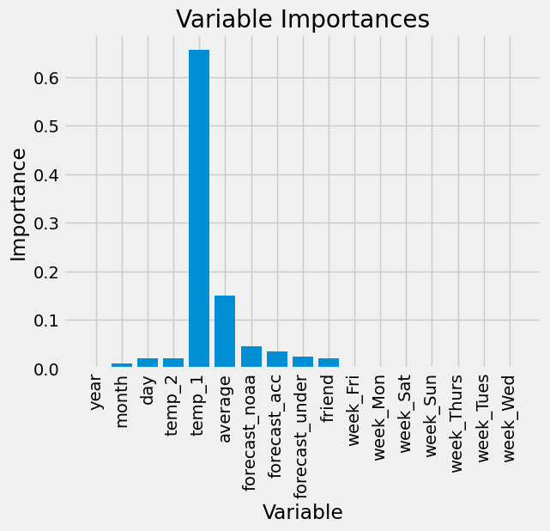

In [18]:

*# Use datetime for creating date objects for plotting*

import datetime

*# Dates of training values*

months = features[:, feature_list.index('month')]

days = features[:, feature_list.index('day')]

years = features[:, feature_list.index('year')]

*# List and then convert to datetime object*

dates = [str(int(year)) + '-' + str(int(month)) + '-' + str(int(day)) for year, month, day in zip(years, months, days)]

dates = [datetime.datetime.strptime(date, '%Y-%m-%d') for date in dates]

*# Dataframe with true values and dates*

true_data = pd.DataFrame(data = {'date': dates, 'actual': labels})

*# Dates of predictions*

months = test_features[:, feature_list.index('month')]

days = test_features[:, feature_list.index('day')]

years = test_features[:, feature_list.index('year')]

*# Column of dates*

test_dates = [str(int(year)) + '-' + str(int(month)) + '-' + str(int(day)) for year, month, day in zip(years, months, days)]

*# Convert to datetime objects*

test_dates = [datetime.datetime.strptime(date, '%Y-%m-%d') for date in test_dates]

*# Dataframe with predictions and dates*

predictions_data = pd.DataFrame(data = {'date': test_dates, 'prediction': predictions})

*# Plot the actual values*

plt.plot(true_data['date'], true_data['actual'], 'b-', label = 'actual')

*# Plot the predicted values*

plt.plot(predictions_data['date'], predictions_data['prediction'], 'ro', label = 'prediction')

plt.xticks(rotation = '60');

plt.legend()

*# Graph labels*

plt.xlabel('Date'); plt.ylabel('Maximum Temperature (F)'); plt.title('Actual and Predicted Values');

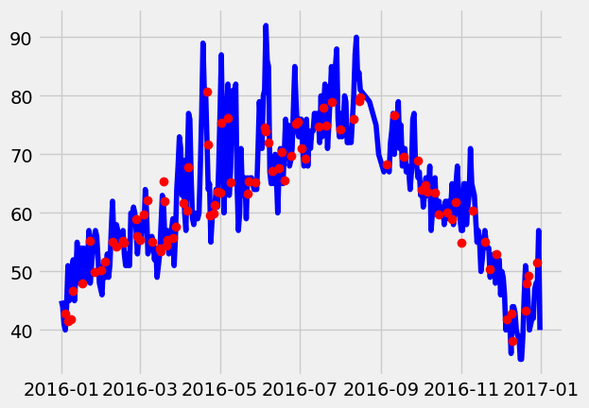

In [19]:

*# Make the data accessible for plotting*

true_data['temp_1'] = features[:, feature_list.index('temp_1')]

true_data['average'] = features[:, feature_list.index('average')]

true_data['friend'] = features[:, feature_list.index('friend')]

*# Plot all the data as lines*

plt.plot(true_data['date'], true_data['actual'], 'b-', label = 'actual', alpha = 1.0)

plt.plot(true_data['date'], true_data['temp_1'], 'y-', label = 'temp_1', alpha = 1.0)

plt.plot(true_data['date'], true_data['average'], 'k-', label = 'average', alpha = 0.8)

plt.plot(true_data['date'], true_data['friend'], 'r-', label = 'friend', alpha = 0.3)

*# Formatting plot*

plt.legend(); plt.xticks(rotation = '60');

*# Lables and title*

plt.xlabel('Date'); plt.ylabel('Maximum Temperature (F)'); plt.title('Actual Max Temp and Variables');

